Secure Shell (SSH) into Amazon EC2

Alen Ovalles

Purpose

The purpose of this lab/lesson is to build a cloud webserver, creating a key pair, and SSH into the Amazon Elastic Compute Cloud (EC2) instance. Using SSH when launching the instance, it asks for a specific key pair.

Process with Pictures

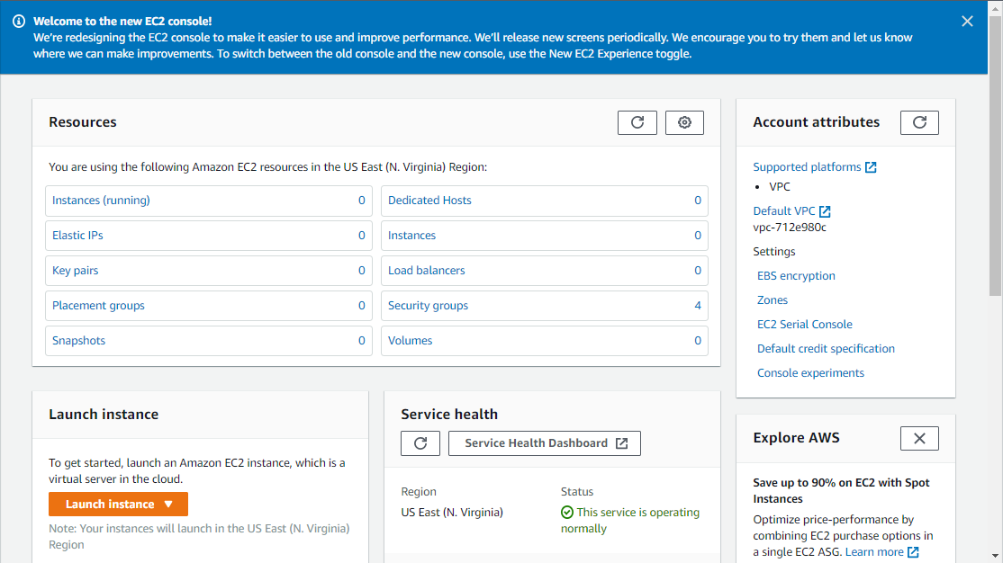

**Step 1:** Launch EC2 Instance

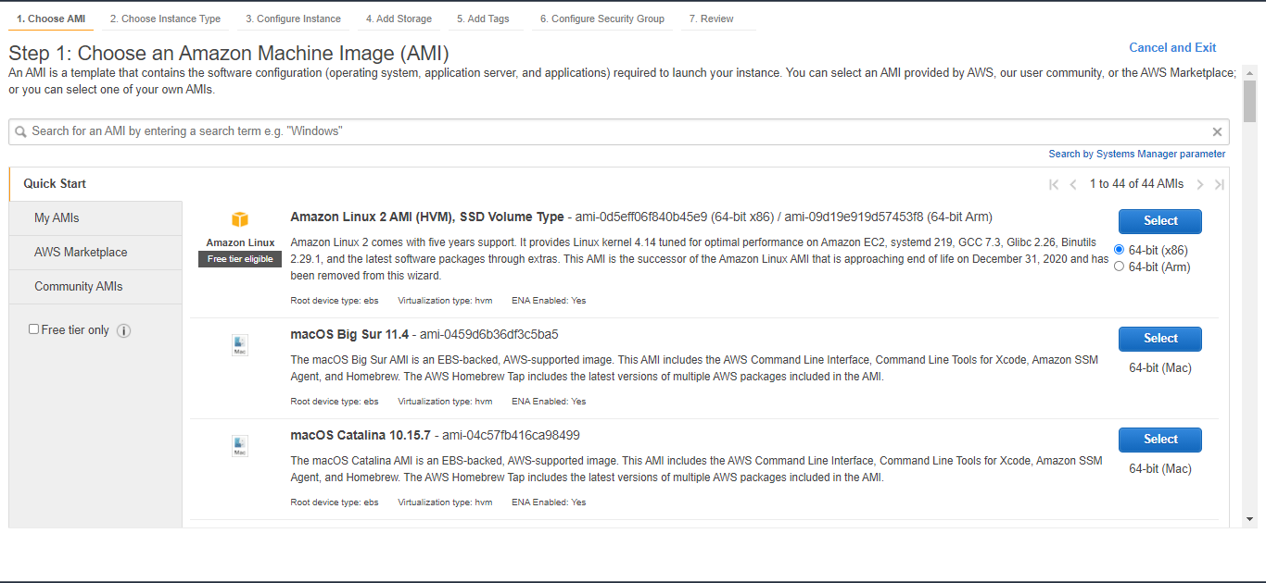

**Step 2:** Select the Amazon Linux 2 AMI (HVM)

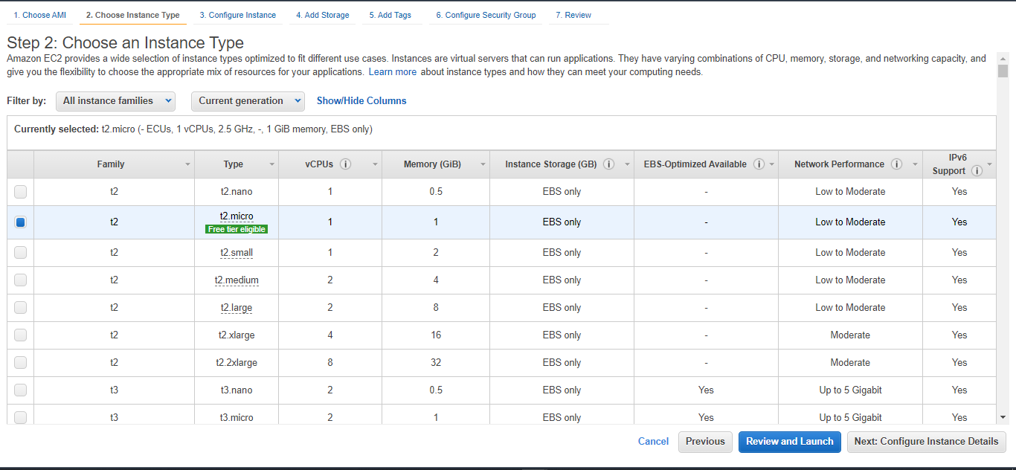

**Step 3:** Select the t2.micro instance type

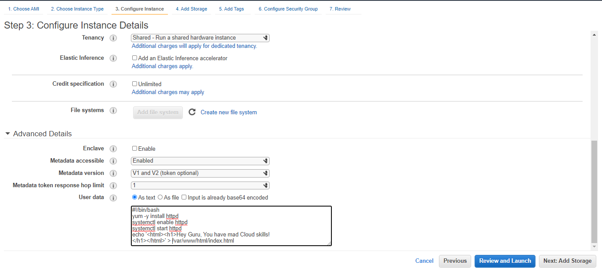

**Step 4:** Enter the User Date as bootstrapping

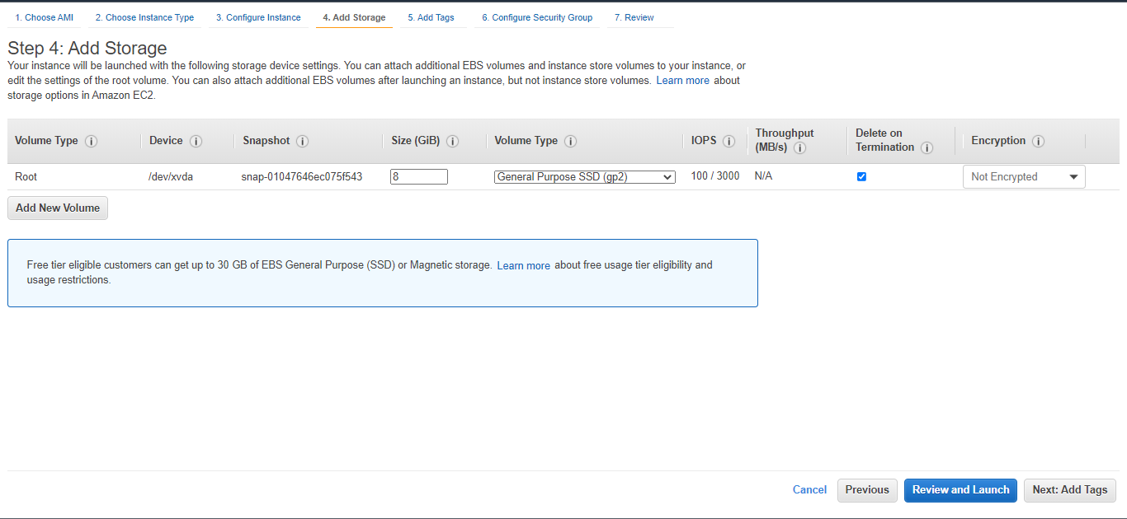

**Step 5:** Don’t change/add storage, just click next

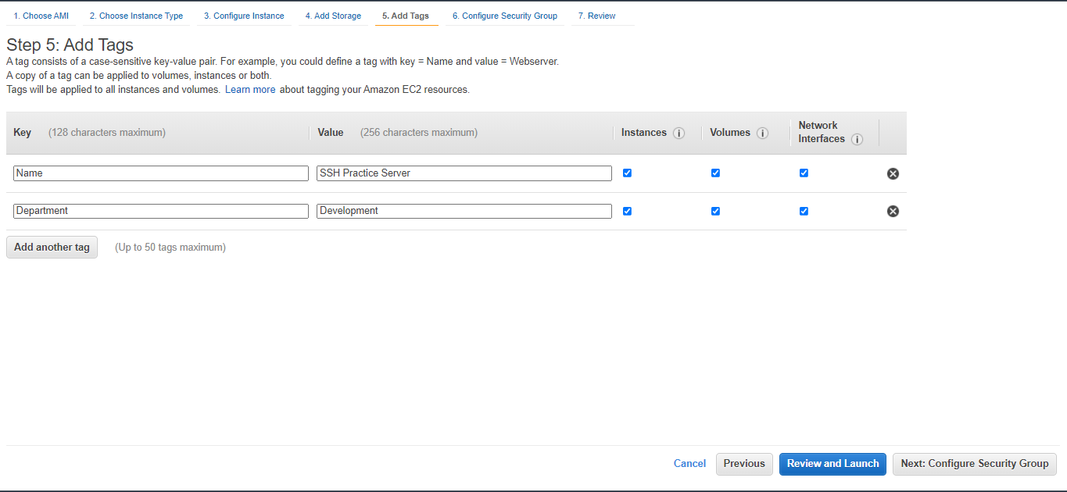

**Step 6:** Add new tags; Key: Name | Value: SSH Practice Server | Key: Department | Value: Development

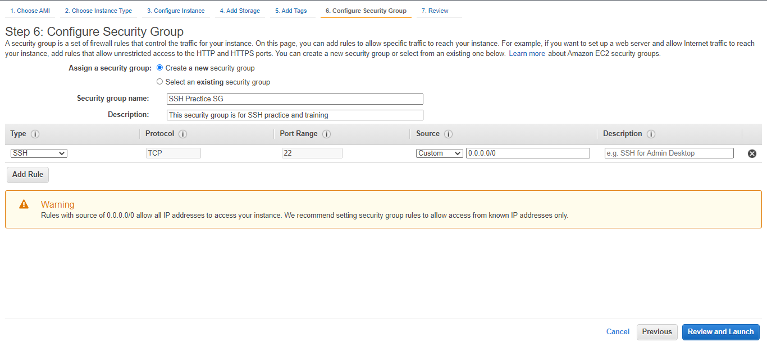

**Step 7:** Security Group Name: SSH Practice SG | Description: This security group is the SSH practice and training

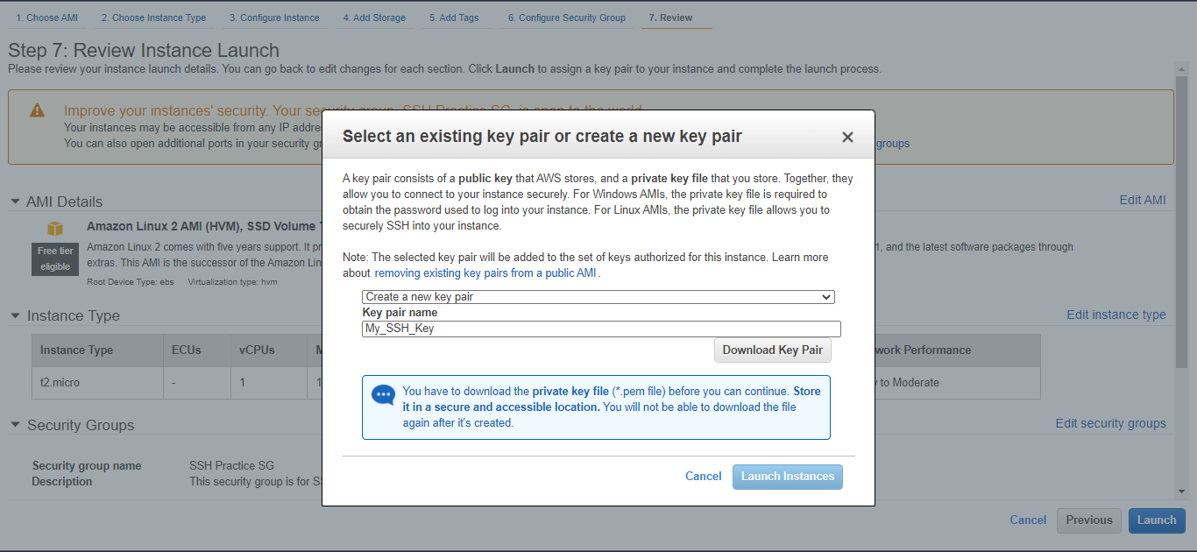

**Step 8:** Create a new pair key; Name: My_SSH_Key

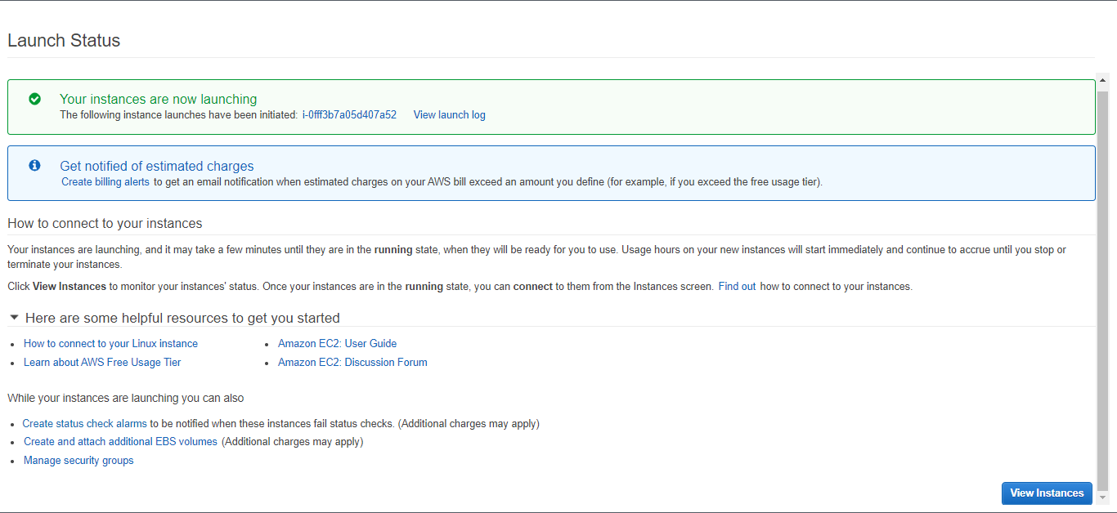

**Step 9:** Acknowledge that the EC2 instance successfully launched

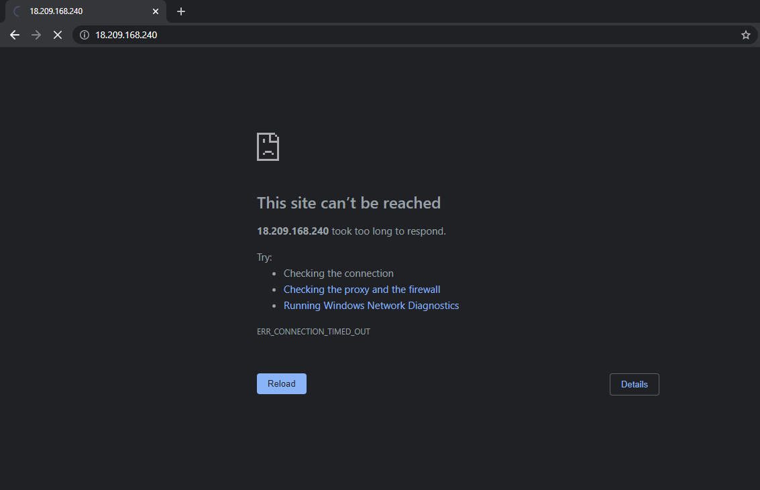

**Step 10:** Check connectivity with newly created EC2 instance with the public ip address

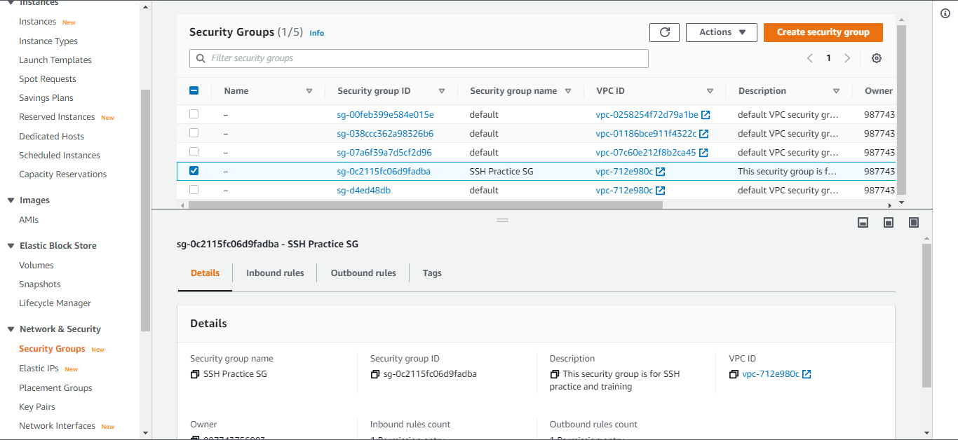

**Step 11:** Highlight and select the create SSH Practice SG

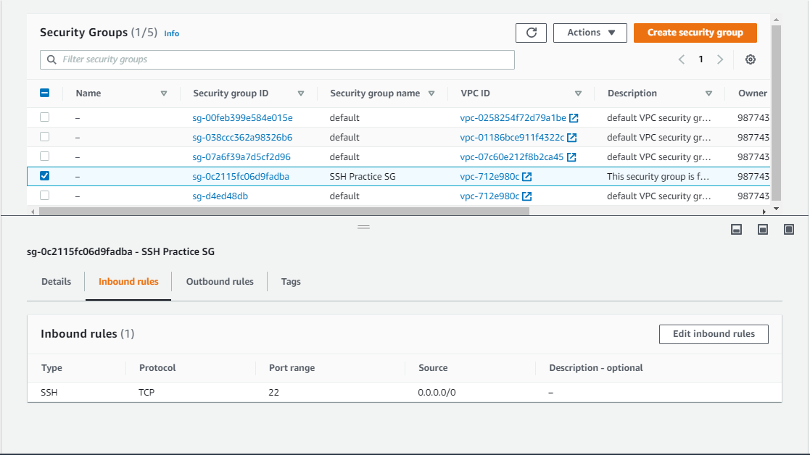

**Step 12:** Navigate to Inbound Rules and click the edit inbound rules button

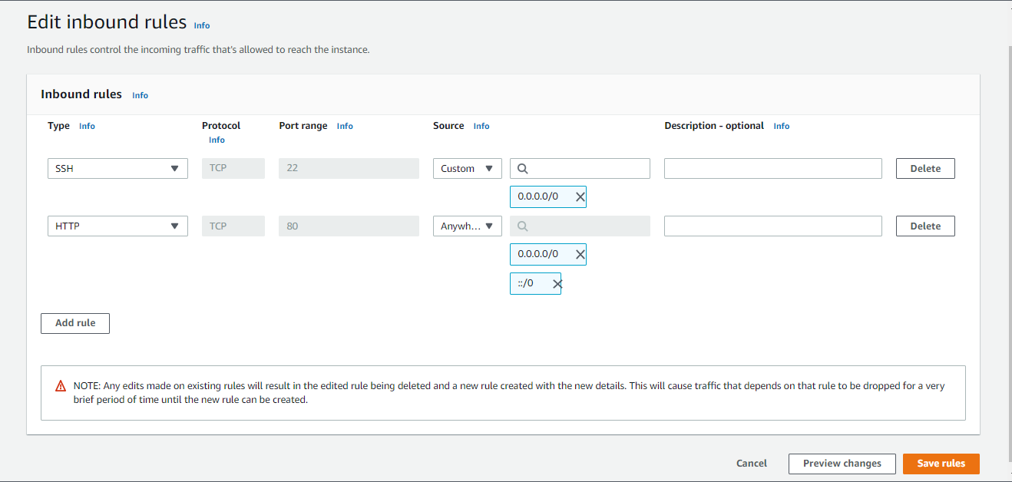

**Step 13:** Add an HTTP type inbound rule to the EC2 instance

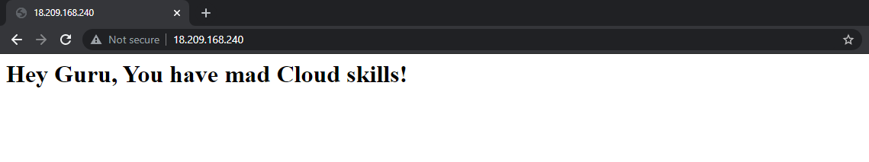

**Step 14:** Check connection, then open PuTTygen to connect SSH

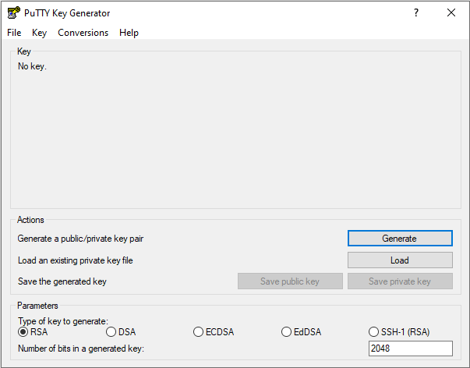

**Step 15:** Click the Load button and upload the downloaded SSH key

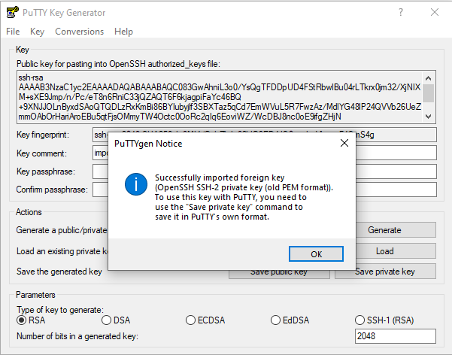

**Step 16:** Acknowledge the pop-up message

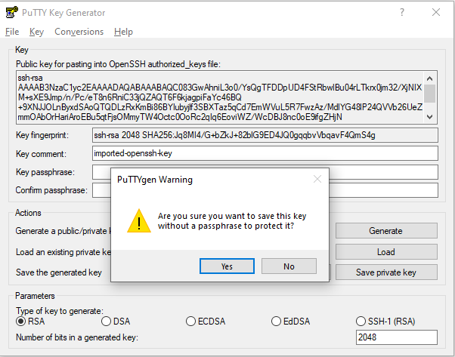

**Step 17:** Select Yes and close PuTTygen, then open PuTTy

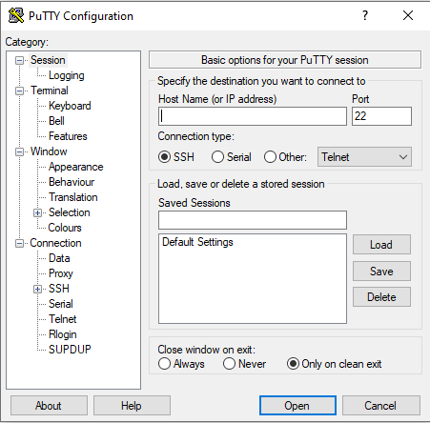

**Step 18:** Enter Amazon EC2 public ip address in the Host Name bar

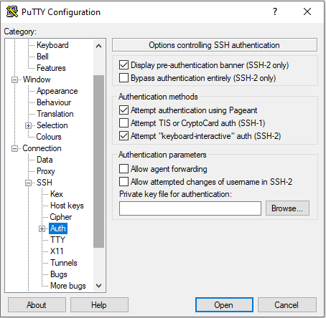

**Step 19:** Navigate to the Auth tab under the SSH tab on the left

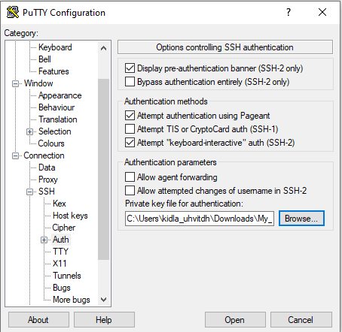

**Step 20:** Find the downloaded SSH key and press Open

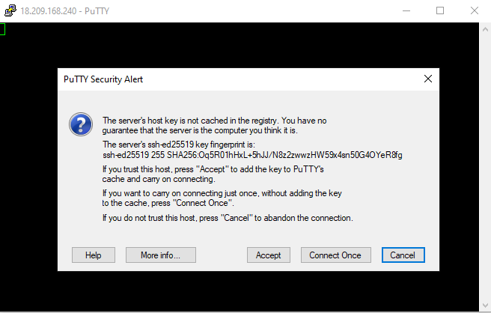

**Step 21:** Press the Accept button to continue

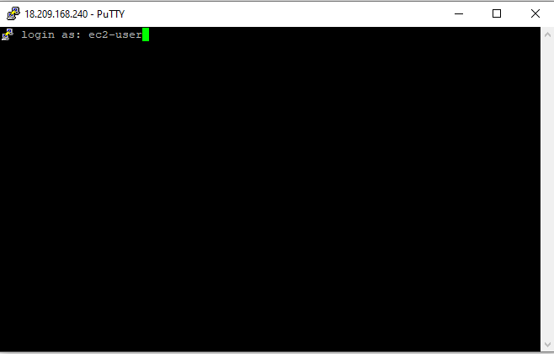

**Step 22:** Login as “ec2-user” and press enter

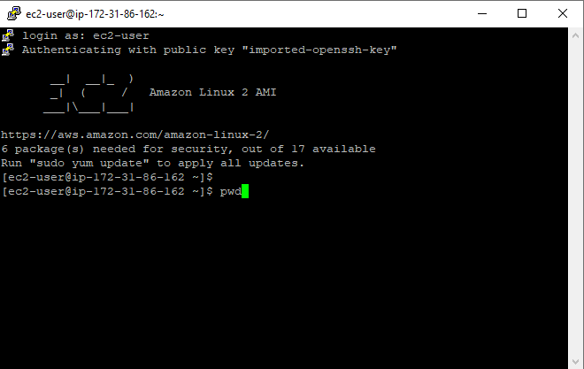

**Step 23:** Enter “pwd” into a new console line

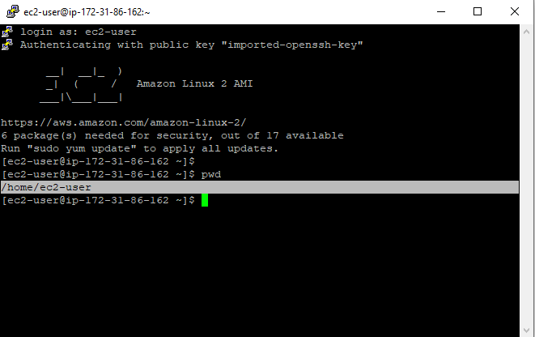

**Step 24:** Should return “/home/ec2-user”

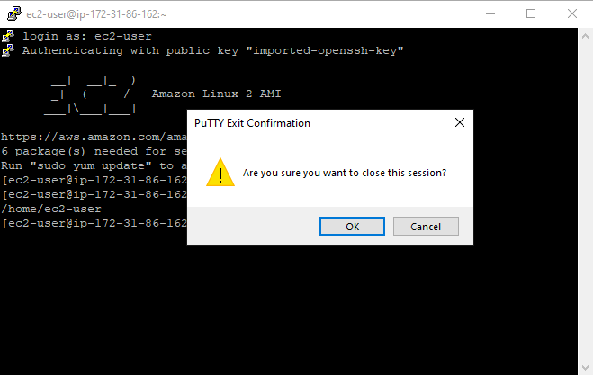

**Step 25:** Close PuTTy console and have successfully connected SSH

Problems

Overall, this lesson had a couple of small problems. Looking over the lab before to see what I need to do was helpful because I needed to download PuTTy and PuTTygen. There were minor problems with the language from the pdf about the lab at the PuTTy section, but it when smoothly right after that.